PLEASE NOTE REVIEW BEFORE REGISTERING:
- All Learn to Skate (LTS) skaters must be 4 years of age and older by July 1/2022.
- The required equipment can be found here: Details of equipment needed per group
- For skaters New Learn to Speed Skate athletes (Group C) can order gear via: https://ilovespeedskating.com/product/beginner-safety-kit.
- Skate rental appointments to be announced on social media or our website. Please check our page for updates here.
PRIOR TO REGISTRATION, YOU WILL NEED THE FOLLOWING:
- Medicare number
- Fredericton Recreation Card Number* via City of Fredericton.
You must have a number generated before completing your IceReg account.
** this is not mandatory region, but please provide if this is applicable.
REGISTRATION STEPS
Step 1 | Access IceReg using the link you were provided, or click here
Step 2 | You will now receive a screen detailing the groups and registration fees. When you are ready to proceed, please click the “Register Now” button located on the right-hand OR lower part of the screen.
 | 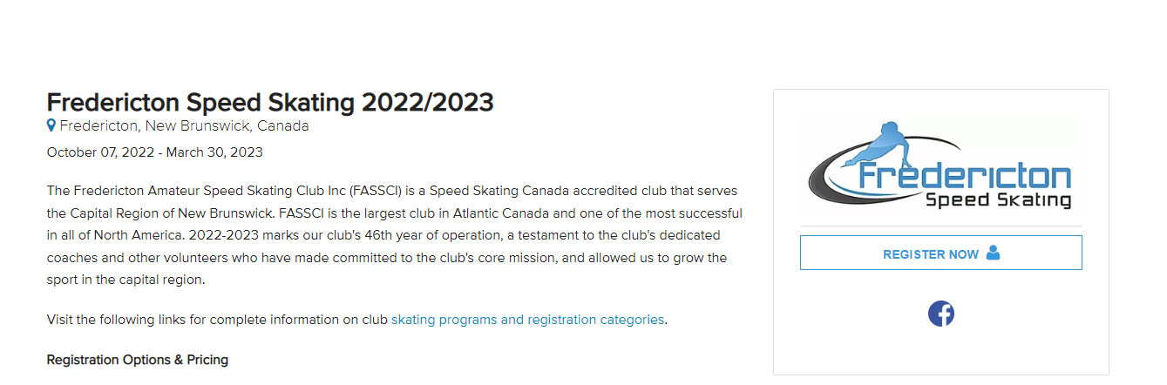
Step 3 | You will be prompted to “Login” under their old account details, or “Create an Account”. New members will need to create an ICEREG account.
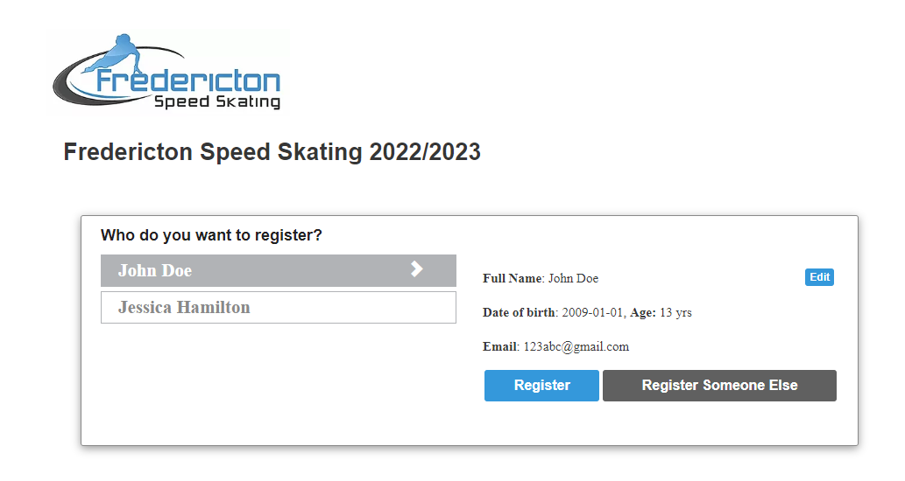
For returning users, you may register by using the previously added skater, and can also add additional “participants” under the same account.
Step 4 | On successful “Login”, you will receive your personalized landing page, which should present you with persons registered under the same account. By using the side bar, select and toggle through which skater you would like to register  - Please review the skater’s information and update using the “Edit” option if necessary.  For new users, follow the prompts and complete the details as requested. The email provided will be your email login.  - Ensure that the address and phone number listed is correct.
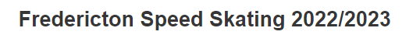
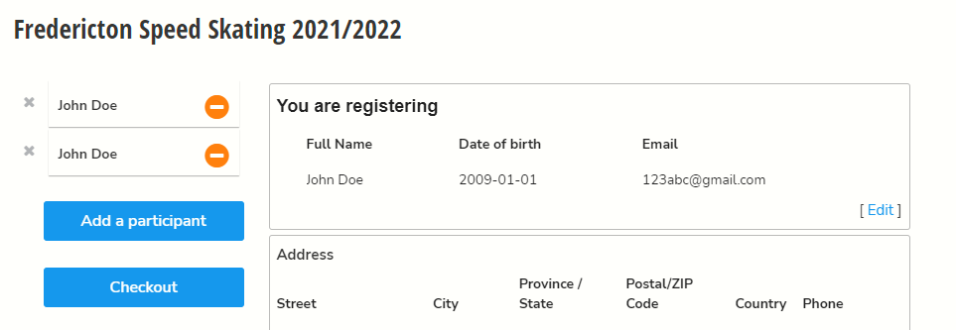
Step 5 | Scroll down to the type of membership you would like to purchase. Please note that the options available reflect the age eligibility for the participant. Select “Next” when complete.
 | 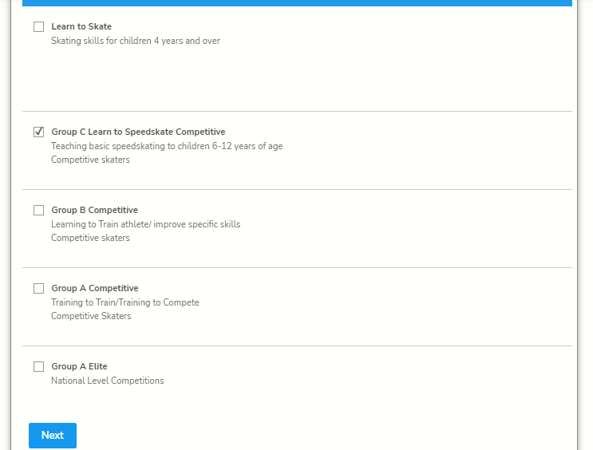
Step 6 | You will receive a notice to add a membership from Speed Skate New Brunswick -> please choose “Add Membership to Cart”.  This will present you with an additional screen which you must complete for your skater. You may already have a stored address and if that is correct you can select that from the drop-down. Otherwise complete the form and continue.
 | 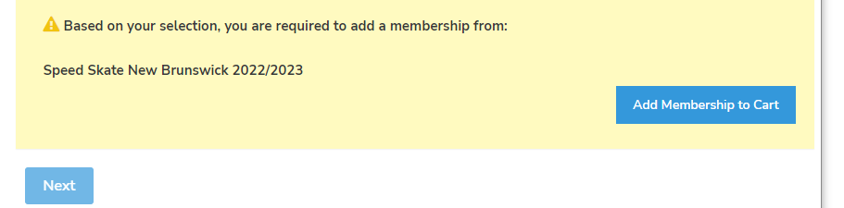
Step 7 | Step 7.1 – You will be brought to a new page to select your membership type. Please note the difference between membership types is listed under “Learn More”. You may select more than one membership type per registrant, but you will be charged for the most expensive membership. **Upgrades to membership types may be made at any time during the year.  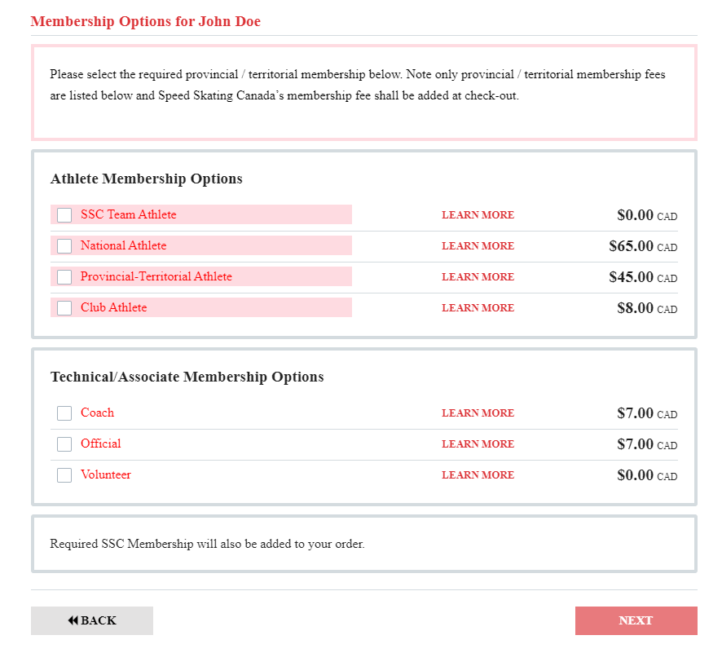
Step 7.2 – Proceed to enter the “Member information” and “Communication consent” and select from the available options and click “Next”.
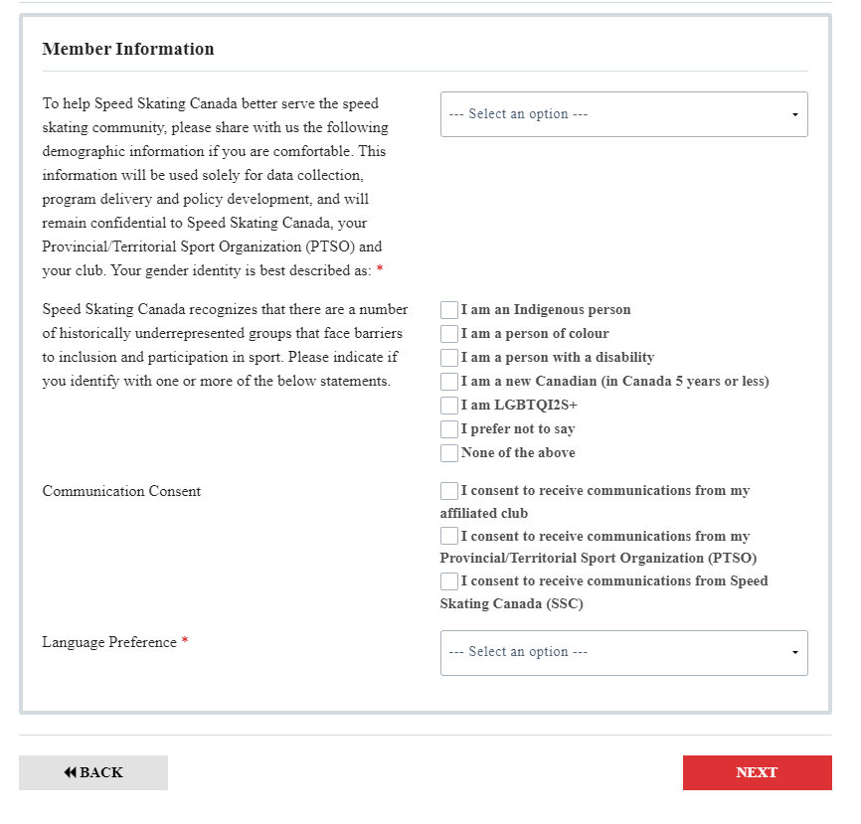
optional

Step 7.3 – You should now be able to select the “Complete and return to registration” option.

Step 8 | At this point, you will be prompted to enter your Medicare number, your Fredericton Recreation Card Number, and your relationship to the skater. Complete the applicable details and then select “Next”.
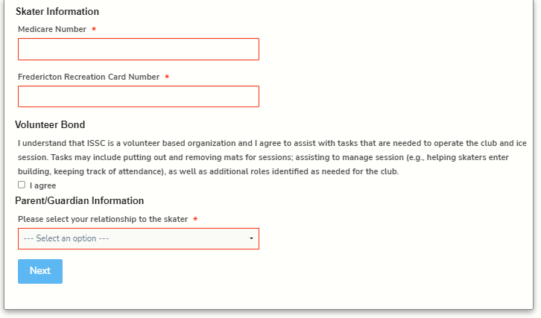
For skaters that do not live in Fredericton region, please contact fassci@gmail.com
Step 9 | Please complete the remaining fields under “You are registering” screen and select “Next”.
Step 10 | You will now be prompted to either “Complete and add another Participant” or “Complete and proceed to Cart”. Please make your selection accordingly. At this stage, please also review all the information and selections.
Step 11 | When you choose “Complete and proceed to Cart”, you will be prompted with waivers and release forms – please complete the necessary fields then review / complete the waiver and continue. PLEASE SELECT I AGREE TO THE ABOVE button on the LEFT, otherwise the form will remain incomplete.
Step 12 | Please review and complete your payment under “Cart Summary”. The breakdown of charges is also listed here. Scroll down to the “Billing & Payment” section to enter in your credit card information for payment. Select “Submit & Complete” upon entering your payment information.
 | 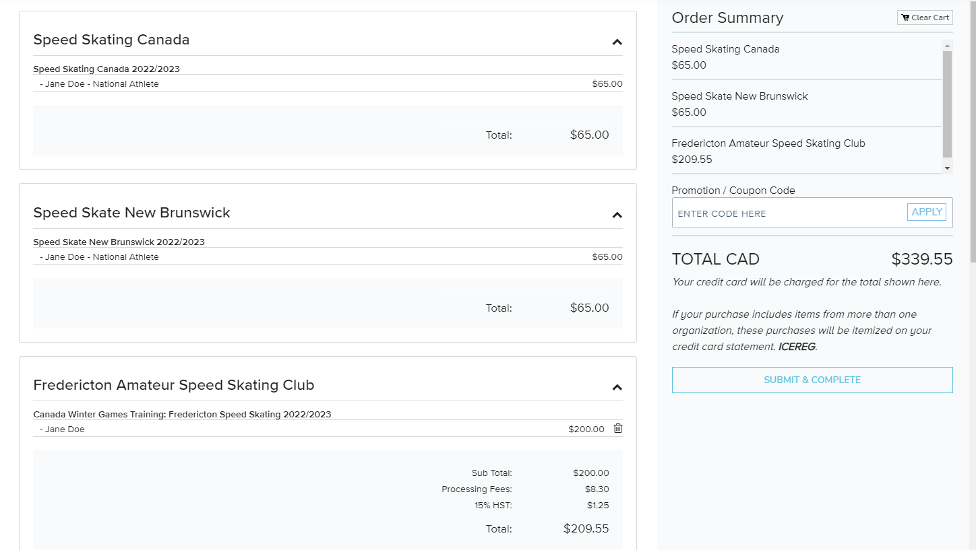

YOU ARE DONE! CONGRATULATIONS! You are now registered for the 2022/2023 season. You should receive a page indicating “Transaction Successful” along with a summary of the charges. You should also receive a “Registration Confirmation” email for each participant that you registered, as well as an email copy of your receipt.

